JAVA CONCEPTS:

IF STATEMENT:

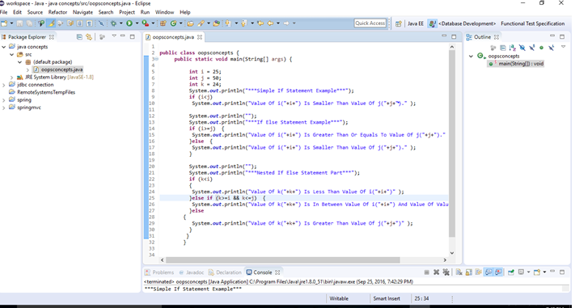

Result:

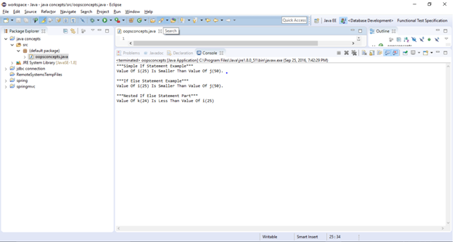

String class in java:

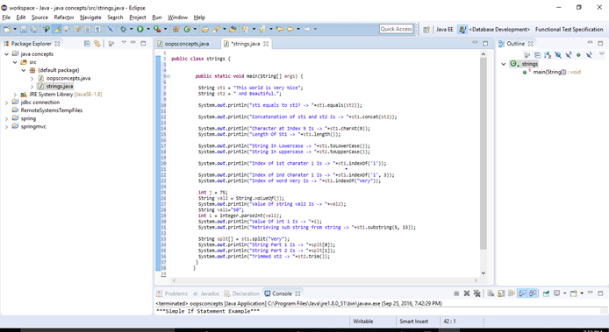

Result:

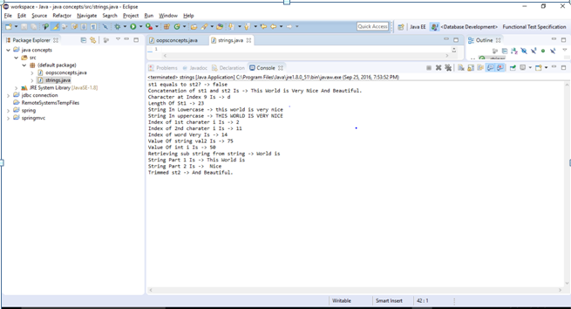

For loop:

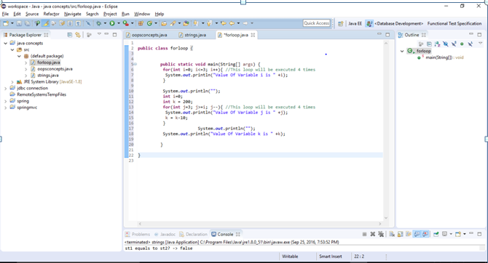

Result:

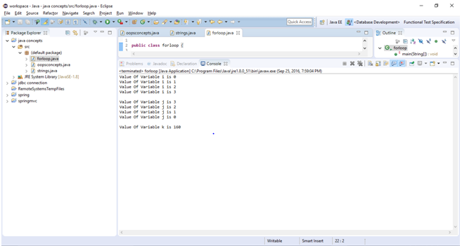

While Loop:

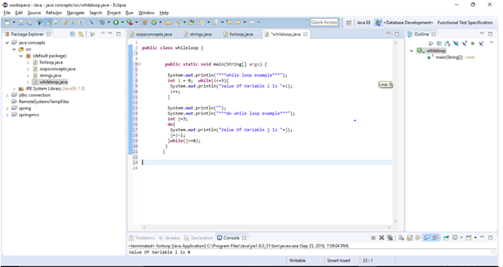

Result:

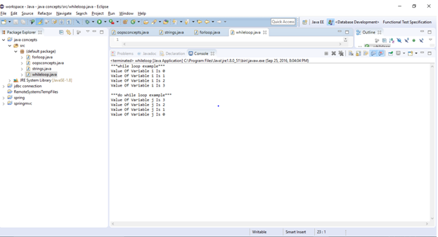

Constructor overloading:

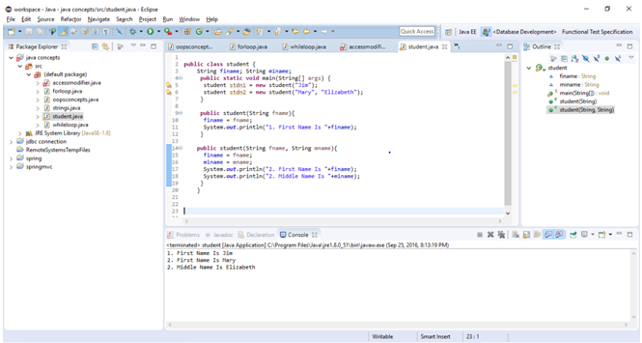

Exception Handlers:

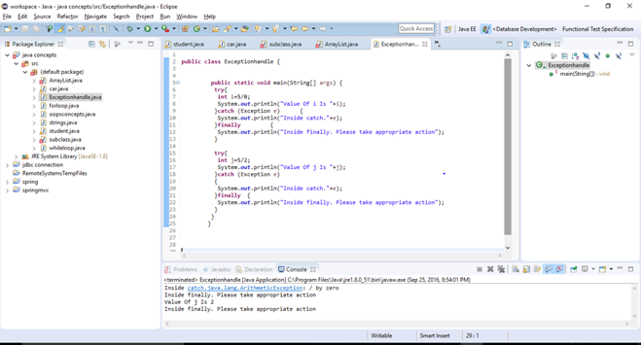

Static non static:

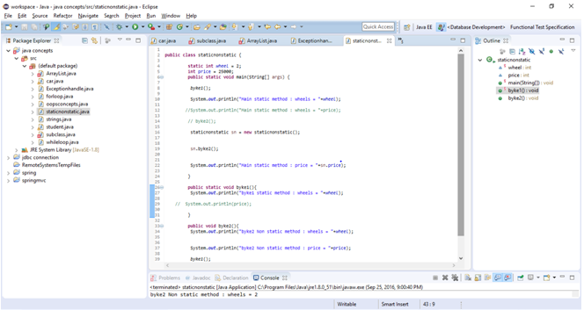

Result:

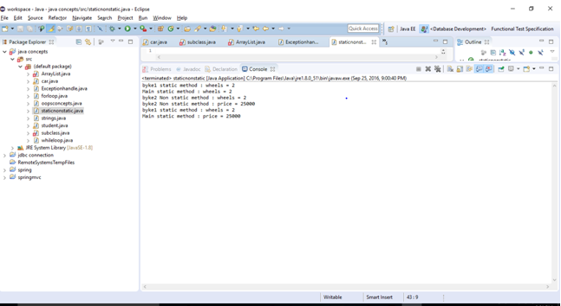

Java concepts:

**public** **class** oopsconcepts {

**public** **static** **void** main(String[] args) {

**int** i = 25;

**int** j = 50;

**int** k = 24;

System.***out***.println("***Simple If Statement Example***");

**if** (i<j)

System.***out***.println("Value Of i("+i+") Is Smaller Than Value Of j("+j+")." );

System.***out***.println("");

System.***out***.println("***If Else Statement Example***");

**if** (i>=j) {

System.***out***.println("Value Of i("+i+") Is Greater Than Or Equals To Value Of j("+j+")." );

}**else** {

System.***out***.println("Value Of i("+i+") Is Smaller Than Value Of j("+j+")." );

}

System.***out***.println("");

System.***out***.println("***Nested If Else Statement Part***");

**if** (k<i)

{

System.***out***.println("Value Of k("+k+") Is Less Than Value Of i("+i+")" );

}**else** **if** (k>=i && k<=j) {

System.***out***.println("Value Of k("+k+") Is In Between Value Of i("+i+") And Value Of Value Of j("+j+")" );

}**else**

{

System.***out***.println("Value Of k("+k+") Is Greater Than Value Of j("+j+")" );

}

}

}

String class in java :

public class Strings {

public static void main(String[] args) {

String st1 = "This World is Very Nice";

String st2 = " And Beautiful.";

System.out.println("st1 equals to st2? -> "+**st1.equals(st2)**);

System.out.println("Concatenation of st1 and st2 Is -> "+**st1.concat(st2)**);

System.out.println("Character at Index 9 Is -> "+**st1.charAt(9)**);

System.out.println("Length Of St1 -> "+**st1.length()**);

System.out.println("String In Lowercase -> "+**st1.toLowerCase()**);

System.out.println("String In uppercase -> "+**st1.toUpperCase()**);

System.out.println("Index of 1st charater i Is -> "+**st1.indexOf('i')**);

System.out.println("Index of 2nd charater i Is -> "+**st1.indexOf('i', 3)**);

System.out.println("Index of word Very Is -> "+**st1.indexOf("Very")**);

int j = 75;

String val2 = **String.valueOf(j)**;

System.out.println("Value Of string val2 Is -> "+val2);

String val1="50";

int i = **Integer.parseInt(val1)**;

System.out.println("Value Of int i Is -> "+i);

System.out.println("Retrieving sub string from string -> "+**st1.substring(5, 13)**);

String splt[] = **st1.split("Very")**;

System.out.println("String Part 1 Is -> "+splt[0]);

System.out.println("String Part 2 Is -> "+splt[1]);

System.out.println("Trimmed st2 -> "+st2.trim());

}

}

For loop:

**public** **class** forloop {

**public** **static** **void** main(String[] args) {

**for**(**int** i=0; i<=3; i++){ //This loop will be executed 4 times

System.***out***.println("Value Of Variable i is " +i);

}

System.***out***.println("");

**int** i=0;

**int** k = 200;

**for**(**int** j=3; j>=i; j--){ //This loop will be executed 4 times

System.***out***.println("Value Of Variable j is " +j);

k = k-10;

}

System.***out***.println("");

System.***out***.println("Value Of Variable k is " +k);

}

}

While loop:

public class Whileloop {

public static void main(String[] args) {

System.out.println("***while loop example***");

int i = 0; while(i<=3){

System.out.println("Value Of Variable i Is "+i);

i++;

}

System.out.println("");

System.out.println("***do while loop example***");

int j=3;

do{

System.out.println("Value Of Variable j Is "+j);

j=j-1;

}while(j>=0);

}

}

While Loop:

**public** **class** whileloop {

**public** **static** **void** main(String[] args) {

System.***out***.println("***while loop example***");

**int** i = 0; **while**(i<=3){

System.***out***.println("Value Of Variable i Is "+i);

i++;

}

System.***out***.println("");

System.***out***.println("***do while loop example***");

**int** j=3;

**do**{

System.***out***.println("Value Of Variable j Is "+j);

j=j-1;

}**while**(j>=0);

}

}

Constructors:

public class Student {

String finame; String miname;

public static void main(String[] args) {

Student stdn1 = new Student("Jim");

Student stdn2 = new Student("Mary", "Elizabeth");

}

public Student(String fname){

finame = fname;

System.out.println("1. First Name Is "+finame);

}

public Student(String fname, String mname){

finame = fname;

miname = mname;

System.out.println("2. First Name Is "+finame);

System.out.println("2. Middle Name Is "+miname);

}

}

Arraylist:

import java.util.ArrayList;

public class ArrayList_Example {

public static void main(String[] args) {

**ArrayList<String> Sample = new ArrayList<String>();**

**Sample.add("button1")**;

Sample.add("button2");

Sample.add("button3");

Sample.add("button4");

for(int i=0; i<**Sample.size()**;i++){

System.out.println(**Sample.get(i)**);

}

System.out.println("*************************");

int ItemIndex = **Sample.indexOf**("button3");

System.out.println("Index Of button3 Item = "+ItemIndex);

System.out.println("*************************");

**Sample.remove(1)**; for(int i=0; i<Sample.size();i++){

System.out.println(Sample.get(i));

}

System.out.println("*************************");

**Sample.set(2, "Button8")**;

for(int i=0; i<Sample.size();i++){

System.out.println(Sample.get(i));

}

}

}

Exception handlers:

public class Handle_exce {

public static void main(String[] args) {

try{

int i=5/0;

System.out.println("Value Of i Is "+i);

}catch (Exception e) {

System.out.println("Inside catch."+e);

}finally {

System.out.println("Inside finally. Please take appropriate action");

}

package Test_Package1;

public class **static_nonstatic** {

static int wheel = 2;

int price = 25000;

public **static** void main(String[] args) {

byke1();

System.out.println("Main static method : wheels = "+wheel);

System.out.println("Main static method : wheels = "+price);

byke2();

static_nonstatic **sn** = new static_nonstatic();

**sn**.byke2();

System.out.println("Main static method : price = "+**sn**.price);

}

public **static** void byke1(){

System.out.println("byke1 static method : wheels = "+wheel);

System.out.println(price);

}

public void byke2(){

System.out.println("byke2 Non static method : wheels = "+wheel);

System.out.println("byke2 Non static method : price = "+price);

byke1();

}

}

try{

int j=5/2;

System.out.println("Value Of j Is "+j);

}catch (Exception e)

{

System.out.println("Inside catch."+e);

}finally {

System.out.println("Inside finally. Please take appropriate action");

}

}

}